# Introduction

There is an identified need for cost-effective analog joysticks that can be used with the Xbox Adaptive Controller (XAC). There are currently not very many commercial joysticks on the market, and the ones that are can be costly. This joystick is intended to be used with the XAC for anyone who may find it easier to game with a joystick.

There is also a need for alternative mouse options that are affordable, and some people may find a joystick easier to use than a standard mouse. This mouse needs to be a standalone device or combination of devices that can be used with PC and can complete the basic mouse functions such as left click.

This joystick specifically is meant for someone with a lower range of motion and lower force compared to some USB joysticks.

# Research

<Existing Commercial Options>

## Commercial Joysticks:

|  |  |  |  |  |  |  |
| --- | --- | --- | --- | --- | --- | --- |
| Name | Price | | Link | | | Picture |
| Ultra-Stik | 95 UK | | [Accessible Gaming Shop - Ultra-Stik - OneSwitch.org.uk](https://www.oneswitch.org.uk/art.php?id=17) | | |  |
| XAC MINI Stick | 105 UK | | [XAC Mini Joystick - OneSwitch.org.uk](https://www.oneswitch.org.uk/art.php?id=270) | | |  |
| Optima Joystick | 219.60 UK | | [Optima Joystick - Video Gaming Assistive Joystick (pretorianuk.com)](https://www.pretorianuk.com/optima-joystick) | | |  |
| PDP One-Handed Joystick for Xbox Adaptive Controller | Out of Stock | | [PDP One-Handed Joystick for Xbox Adaptive Controller (microsoft.com)](https://www.microsoft.com/en-ca/d/pdp-one-handed-joystick-for-the-xbox-adaptive-controller/8qhw8mlwpp1l) | | |  |
| XAC Flat Thumbstick | $74.95 | | [XAC Flat Thumbstick (evilcontrollers.com)](https://www.evilcontrollers.com/xac-flat-thumbstick) | | |  |
| Name | | Price | | Link | Picture | |
| MINISTIX-TU | | $75 | | [MINISTIX-TU (USB Version) — Warfighter Engaged](https://warfighterengaged.org/shop/ministix-tu) |  | |
| DPAD-T | | $65 | | [DPAD-T — Warfighter Engaged](https://warfighterengaged.org/shop/dpad-t) |  | |
| JOYSTIX-FPS | | $75 | | [JOYSTIX-FPS — Warfighter Engaged](https://warfighterengaged.org/shop/joystix-l-aenef) |  | |
| JoyCon® Style Joystick For XBOX® Adaptive Controller & PC (JoyToKey) | | $60.40 | | [Joycon® Style Joystick for XBOX® Adaptive Controller & PC | Etsy Canada](https://www.etsy.com/ca/listing/1205880837/joycon-style-joystick-for-xbox-adaptive?click_key=445335b9946b1ba0aec90589990e5837fda07282%3A1205880837&click_sum=ba40a784&ref=shop_home_active_3&crt=1) |  | |

# Ideation

## Joystick Element

For this design, the same joystick element will be used as the current Analog Thumbstick on the website, which is a standard PS2 thumbstick unit.

There is also a Adafruit version of a similar joystick, this will be looked into as well and the price and availability will be compared.

## Switch Input

There are a few different ways that switch input can be accomplished:

* Integrated buttons
* Integrated switch jacks
* Separate “controller box” that the joystick and switches plug into

The first iteration of this design is now the Cedar Mini Joystick which had integrated jacks, where the users could plug in their assistive switch of choice for switch input. While in mouse mode, these switches are left click, right click, and scroll.

After user testing, the decision was made to proceed with the separate “controller box” or “hub” that the joystick and switches plug into.

# Conceptual Design

The enclosure design for this joystick was based on the [AbleGamers “snap assembly thumbstick shell” in Printables.](https://www.printables.com/model/508909-snap-assembly-thumbstick-shell)

## Concept 1: Joystick snap in assembly

For this, the joystick would snap into the enclosure like it does in the original AbleGamers design.

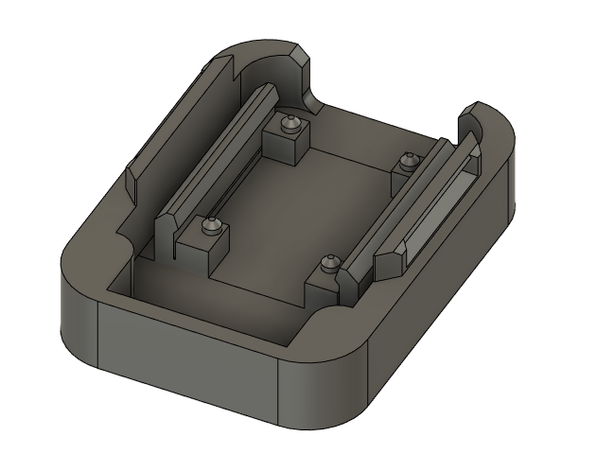

## Concept 2: Joystick screw in assembly

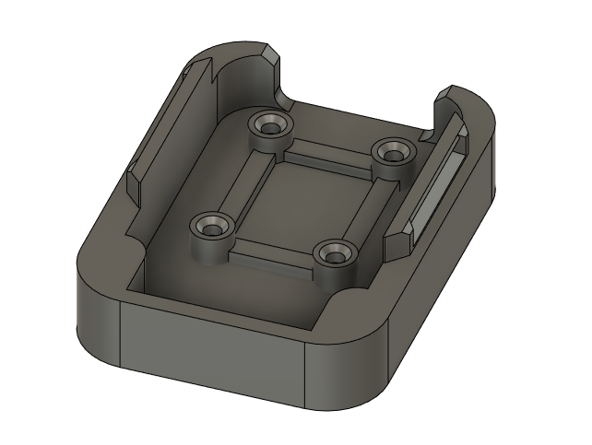

# Prototyping

# Testing

# Detailed Design

## Overview

On the outside of the enclosure, there are a few key features. On the side facing the user, “Spruce” is engraved, and on the side facing away from the user “MMC” is engraved. There is also an arrow on the top of the enclosure showing the up direction.

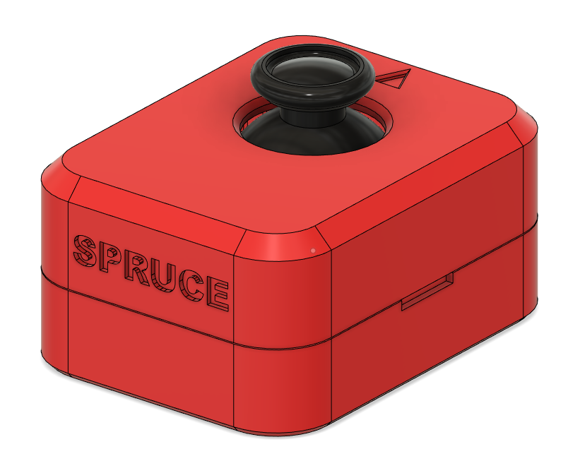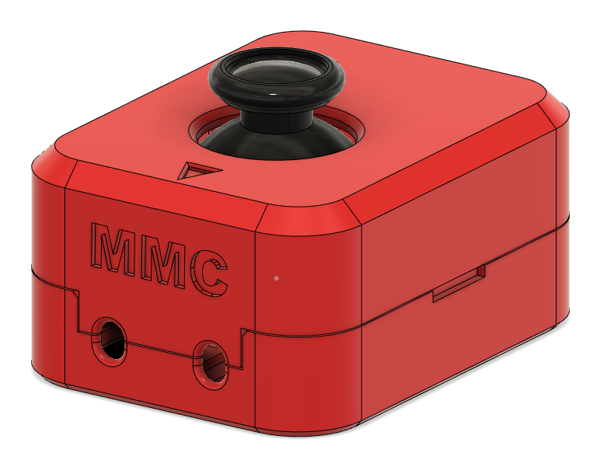

There are two cables that exit the back side of the enclosure (away from the user), both are 3.5 mm audio cables. One of the cables has 4 conductors (TRRS cable) for the joystick output, and one has 2 conductors (mono cable) for the switch output for the press down switch built into the joystick. It was decided that these cables would exit away from the user for better cable management and to be the most out of the way while the joystick is in use.

### Joystick Unit

For this joystick, there are two main joystick/thumbstick units that can be used. Some are commercially available for hobbyists from a few different sources such as Amazon, and then the other unit is the “Adafruit 2-axis Thumb Joystick with Select Button + Breakout Board” which available from some electronics suppliers such as Digikey and Mouser.

Comparing these two joystick units, the ones from Amazon are significantly less expensive, at $20.89 for a pack of 10, whereas the Adafruit unit is $9.13 on Digikey for one unit. For a single build the Adafruit unit would be less expensive, but for 2 or more units it would make sense to use the units from Amazon.

Another consideration here is availability. The Adafruit unit goes in and out of stock, but when it comes back in stock it is the same unit. There seem to be more Amazon units in stock, but they could go out of stock at any time. If they go out of stock a comparable unit can often be found, but it might not be exactly the same, which leads to the point of consistency across units.

Lastly, the consistency and quality of the joystick unit should be considered. The Adafruit unit is going to be more consistent and is guaranteed to always be the same dimensions and quality. Whereas if the Amazon unit goes out of stock and another unit has to be sourced it is not guaranteed to be exactly the same, and the hole spacing and overall quality could be different.

For this iteration of the design, two sets of holes were included so either joystick unit could be used.

## Enclosure Bottom

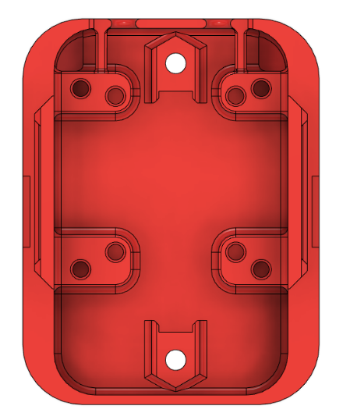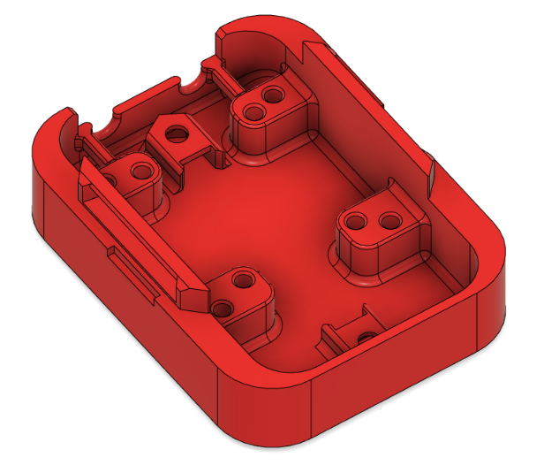

### Joystick Mounting

For the two sets of mounting holes, it was decided to use a #4 sheet metal self tapping screw, similar to other MMC designs such as the Oak Compact Joystick and the MMC60 switch. The thread diameter of this screw is 2.8 mm, and [the best practice for the hole size for self tapping screws](https://www.hydraresearch3d.com/design-rules#threads-post-process) is 96% of the hole diameter, so a hole size of 2.68 mm was used.

The spacing of the holes for the Amazon unit is seen below:

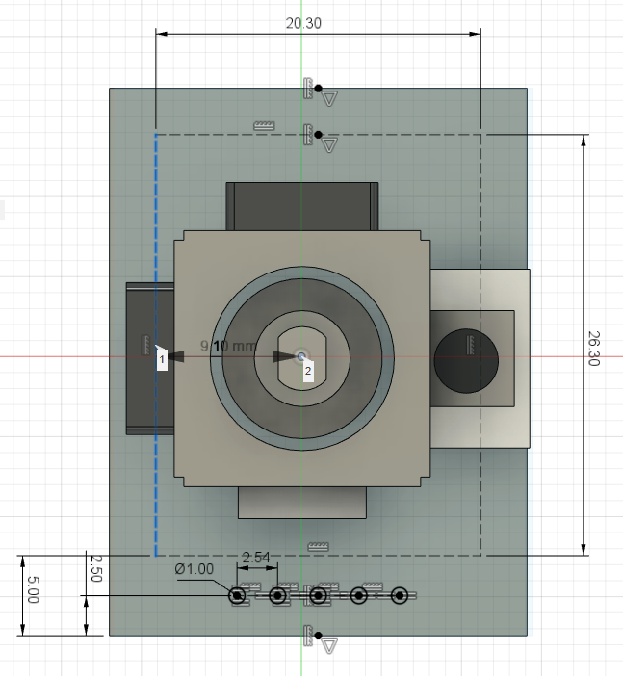

The Adafruit joystick unit has the holes in a square with the joystick centered between the screw holes. The spacing of these screw holes is 30.48 mm as seen below:

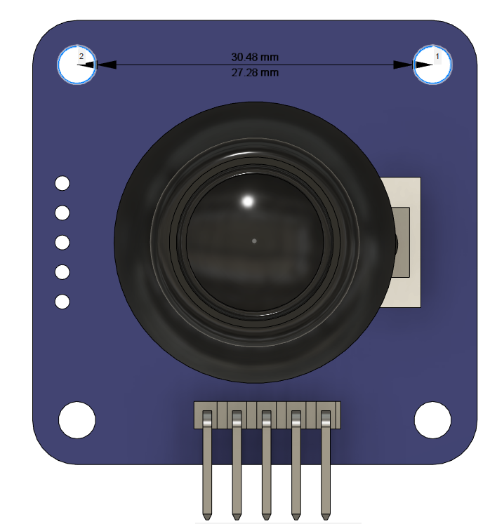

### Mounting – Captive Nuts

It was decided that this design should incorporate a way to mount the joystick when not used on a tabletop. To do this, two slots for captive nuts were added, which would then screw into a separate mount adapter which will have the mounting hardware in it. Here, two M3 hex nuts are used. The centres of these nuts are 50.0 mm apart. There are also small walls added coming out of these captive nut slots to help with alignment of the nut while inserting. These two slots are seen in the photos above, and then in a closer view below. As seen in the photo, around the hole above the captive nut, which would be printed unsupported, there are small single layer rectangles, [this is a best practice when 3D printing unsupported holes.](https://www.hydraresearch3d.com/design-rules#unsupported-holes)

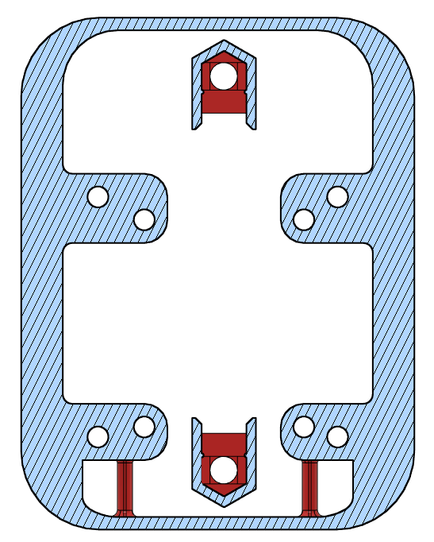 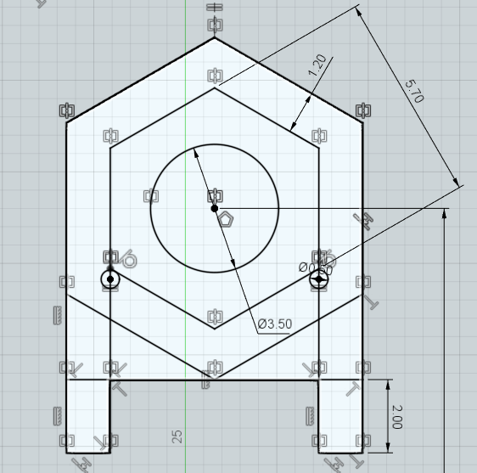

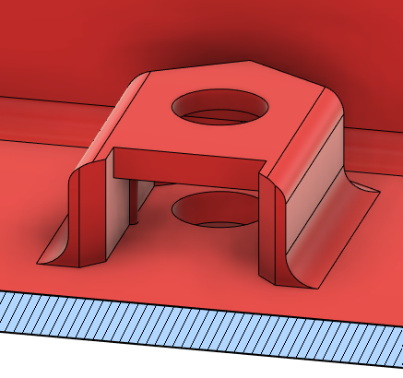

### Cable Strain Relief

Strain relief for the two cables exiting the enclosure was added by adding two small beams where a zip tie could be fastened for each of the cables before they exit the enclosure. The zip ties are shown with the cables in the photo below, and the beams are circled in a picture from the CAD.

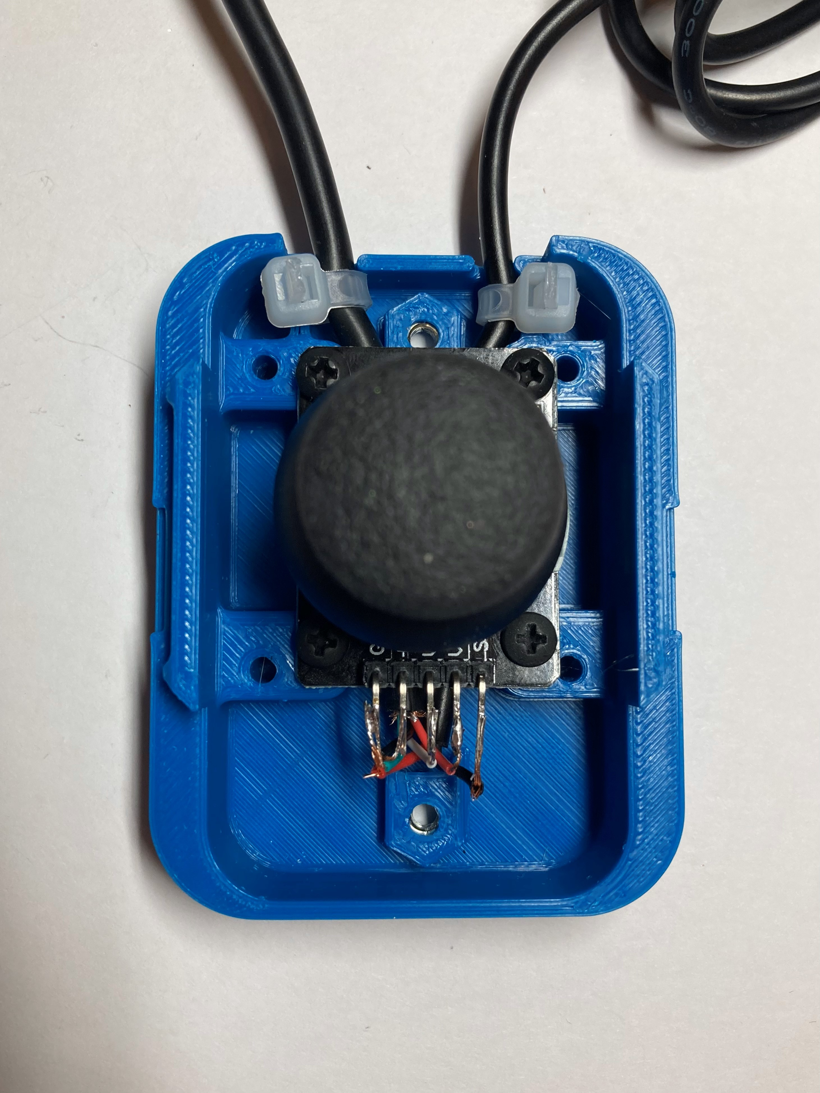 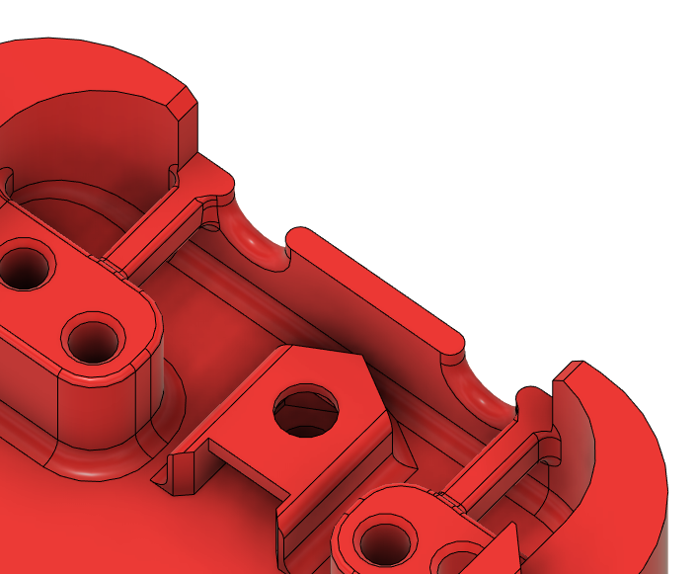

### Enclosure Snap Fit

This design uses a snap fit to connect the top of the enclosure to the bottom of the enclosure.

The piece on the bottom of the enclosure was extruded inwards (cut away from body) 3mm at a taper angle of 45 degrees. The top lip was then chamfered so the top could be inserted easier. The same sketch was used for the top of the enclosure to extrude out 3 mm at a taper angle of 45 degrees, and then the tip was chamfered. The distance between the two surfaces before adding the snap fit was 0.3mm.

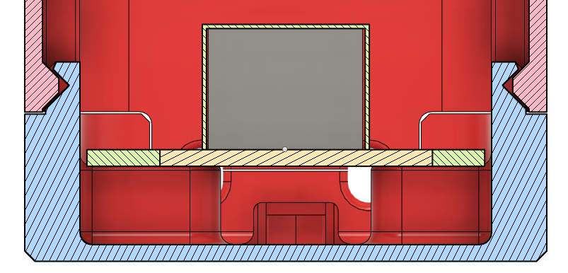

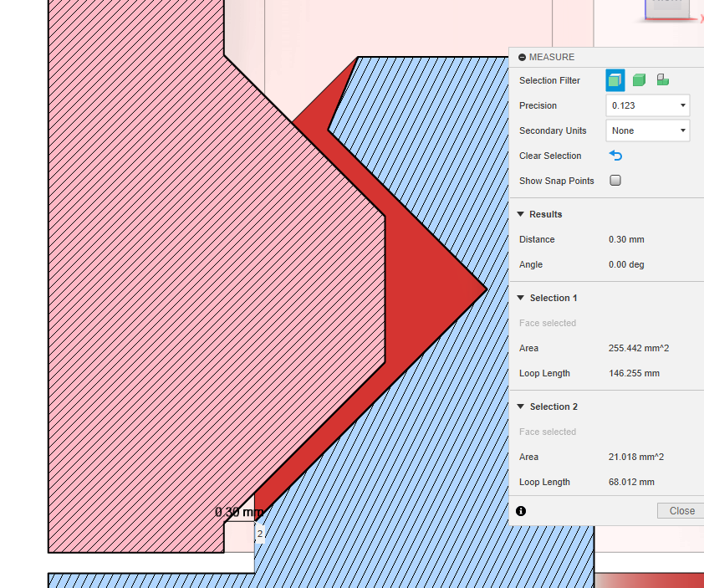

Piece on the bottom enclosure:

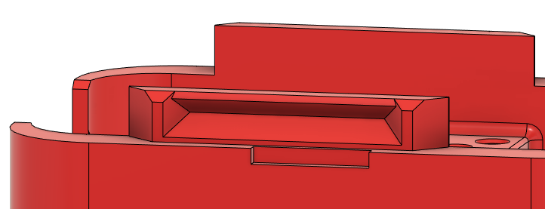

Piece on the top enclosure:

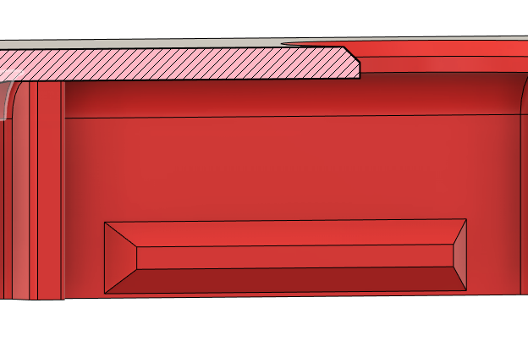

## Enclosure Top

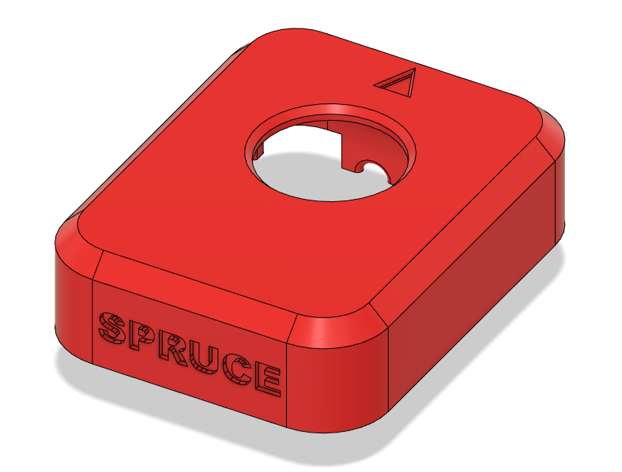 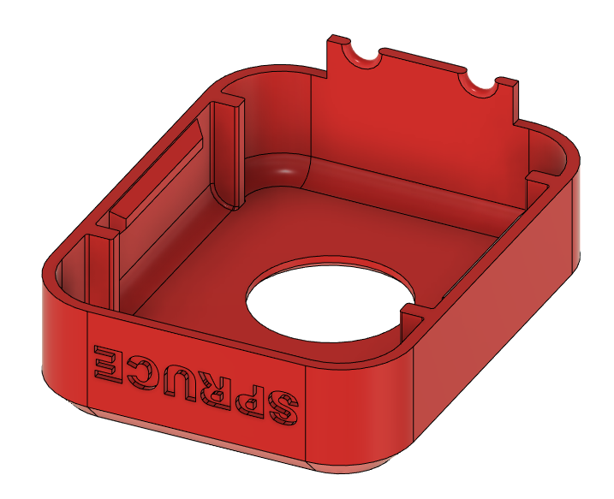

During User Testing with the Cedar Mini Joystick (which used the same joystick unit) it was identified that it is important to not have a large gap between the joystick unit and the enclsoure, where the electronisc can be seen and things could fall into the enclosure during use, such as crumbs or other debris. For this reason, the height on this enclosure was increased and the size of the hole around the joystick was decreased, to decrease this gap.

## Assembled Prototype

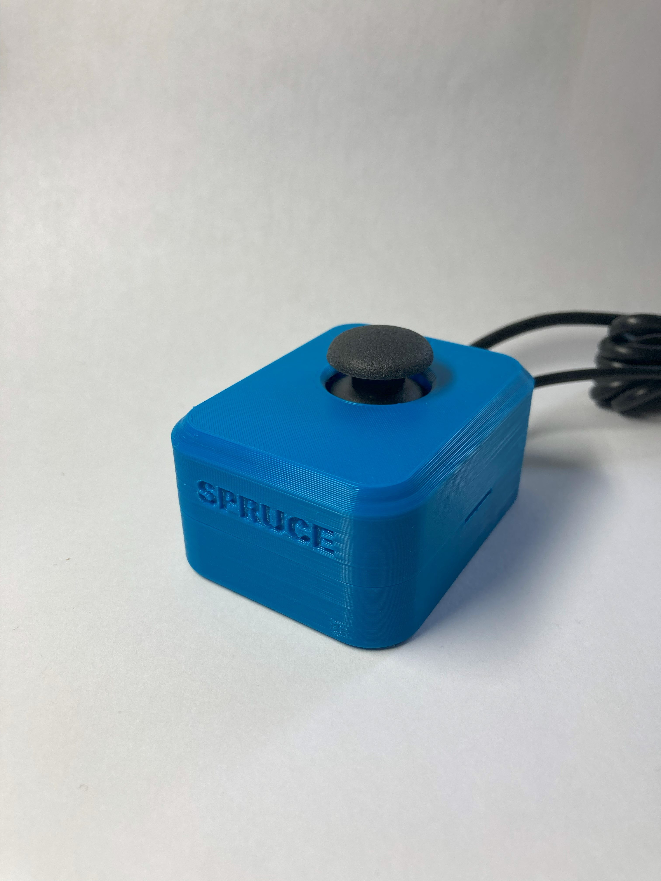 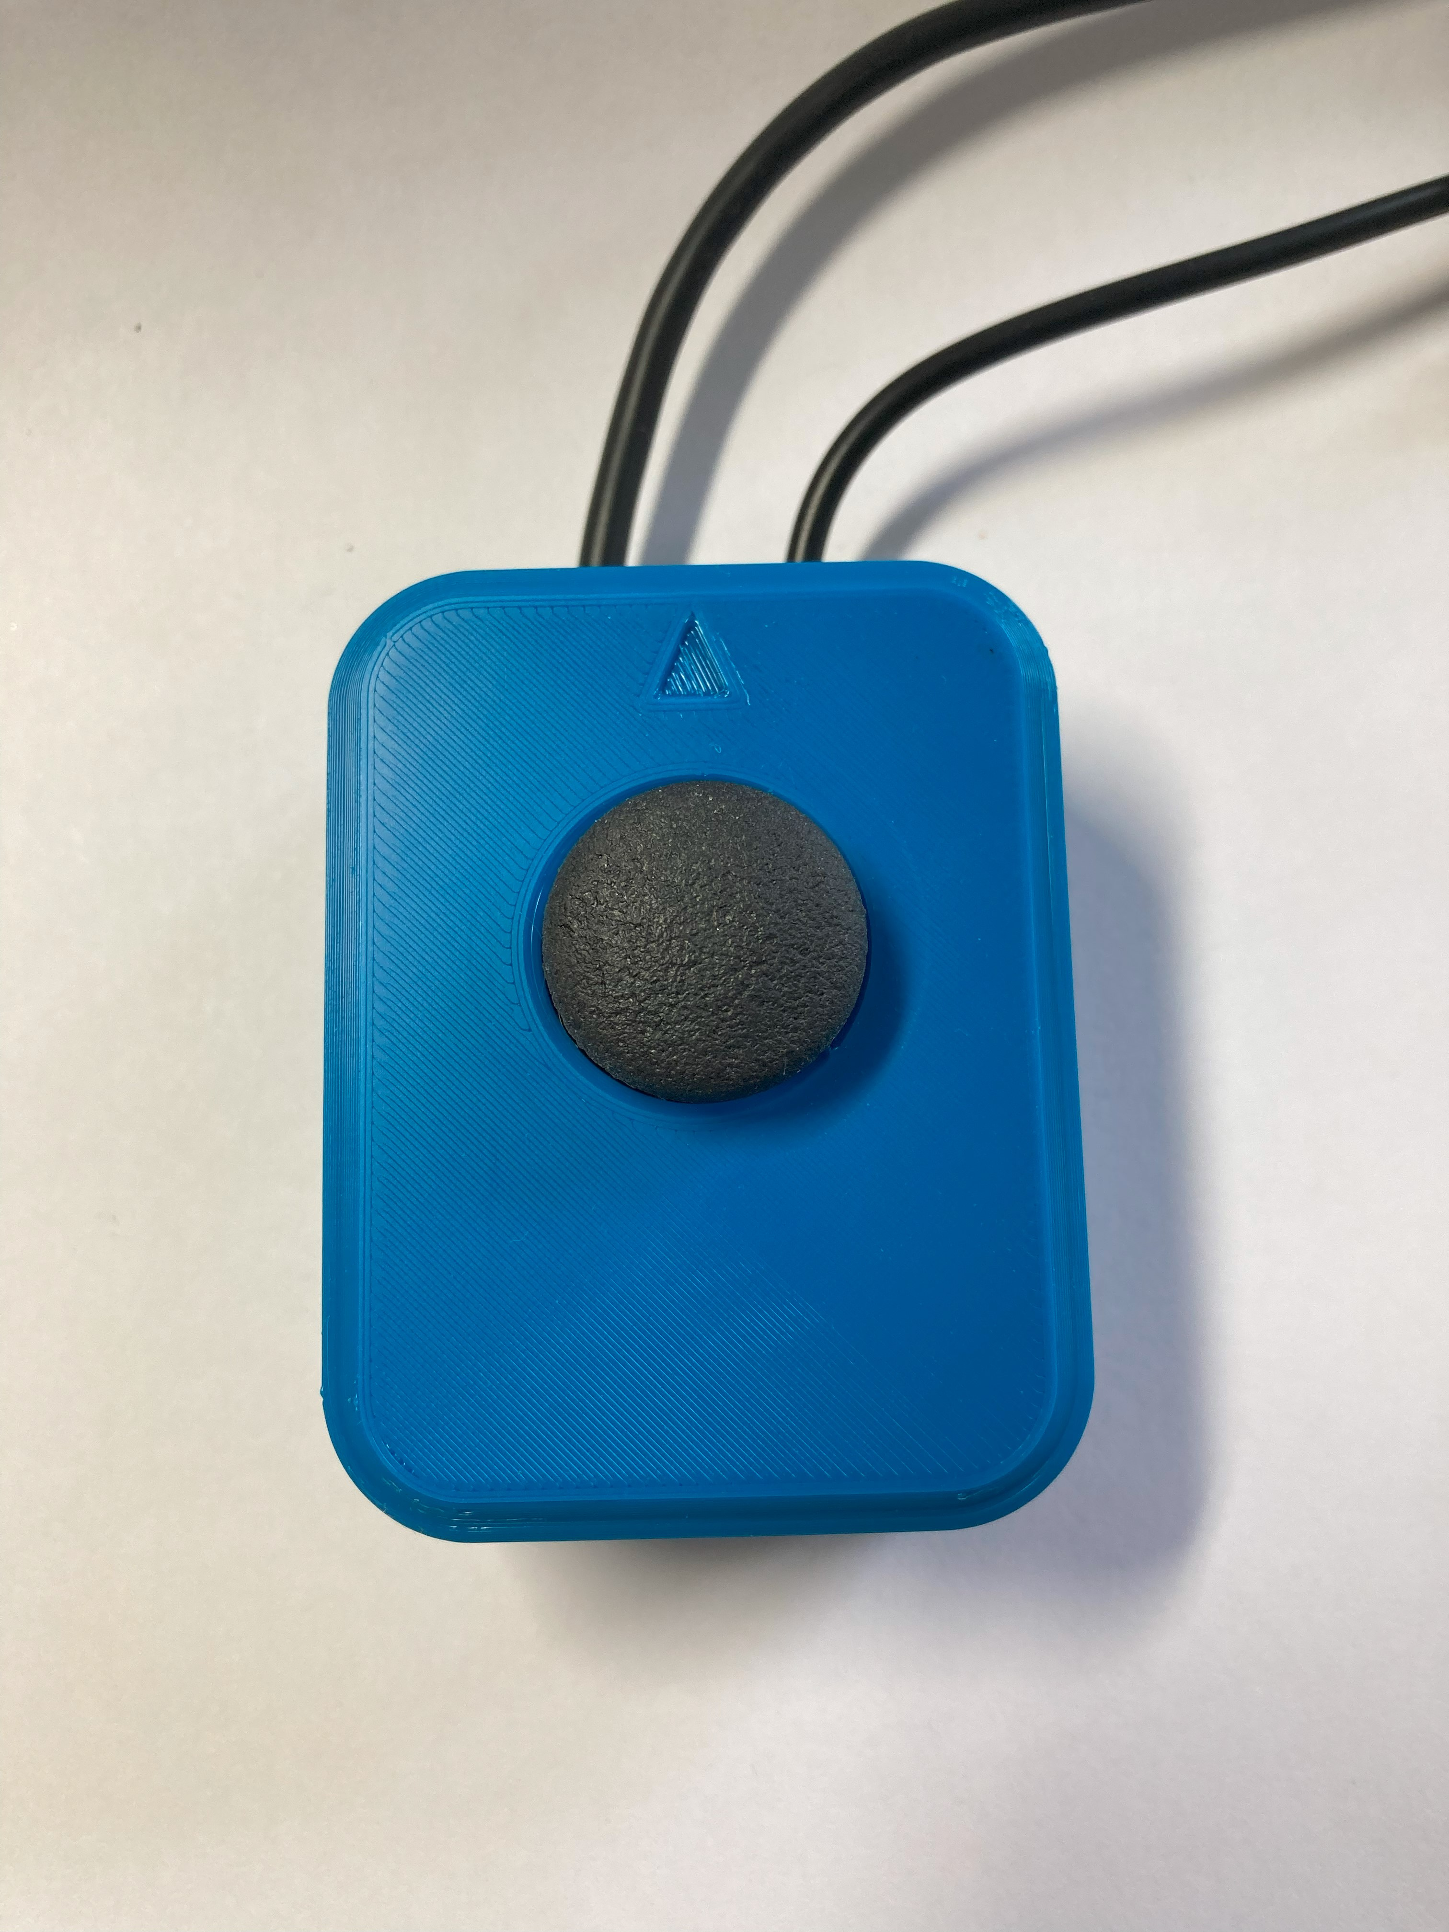

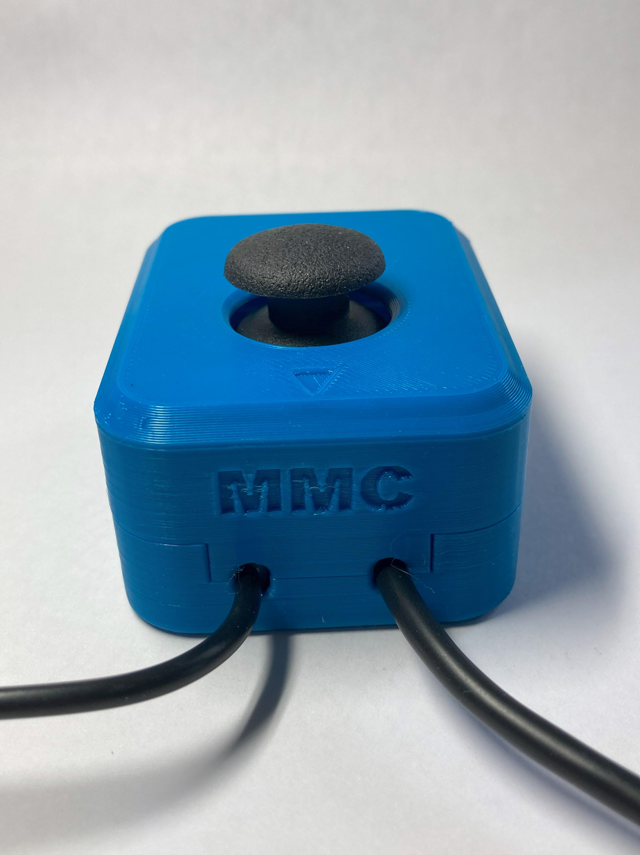 

# Opportunities for Improvement

* Could reduce the height of the enclosure, if possible to keep the fit around the joystick topper
* Add a feature to the outside of the enclosure to allow for snap on pieces for wrist supports and other bases